CITY UPDATE

Building Inspector | Police Chief | Reminders

**New Building Inspector**

At the April 8th meeting, the City Council entered into a 1 year contract with Prokore Inspections, LLC, out of Mankato, for building inspection services

Prokore has an online option to complete a permit application at: [www.korepermit.com/application/](http://www.korepermit.com/application/).

You may also come into the City Office for all permits.

At this time permit fees

will remain the same.

Randy King is our contact with Prokore and all building inspection questions can be

addressed by calling him

at 507-388-4224. Eventually, it is hoped that all building permits will be handled directly through Prokore with minimal involvement with the City. We look forward to working with Randy and his company.

Continued on next page

**New Police Chief**

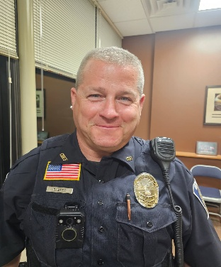

Douglas Best officially started as the new Chief of Police on Monday, April 14th. Chief Best plans on working with the community, civic organizations, and city staff to look out for the best interest of the City of Brownton and its citizens. This will not only include the traditional “Protect and Serve” role, it will also involve being active in other areas like the Baseball Association, youth softball and starting education programs to prevent fraud and abuse.

“I have enjoyed living and growing up in a small town. Brownton has a very nice small town feel. I want to help be a part of keeping that small town comfort while balancing the duties of having a well run and respected police department that can properly serve the community.

“I’m very approachable, outgoing, and don’t mind having people stop and chat. I look forward to meeting people around town,” Chief Best said.

Building Inspection Cont.

Why do you need a building permit?

Obtaining a building permit ensures your construction project complies with local building codes and regulations, which are in place to protect public safety and property values. It also provides legal authorization to proceed with construction and can help protect against future legal and financial issues. 

Having a permit provides peace of mind knowing your project is legal and meets the necessary standards.

It can also protect you from legal and financial repercussions if the work is discovered to be non-compliant after the fact.

The permit process also provides a record of the work done on your property, which can be helpful in future property transactions or assessments.

REMINDERS:

How to deal with feral cats.

While feeding feral cats might seem like a compassionate act, it is not recommended due to the potential harm it can cause to the cats, wildlife, and the environment. Feeding can lead to overpopulation, dependency, health problems, and conflicts with other animals.

Overpopulation: Feeding attracts more feral cats, leading to a breeding cycle with worsens the problem.

Dependency: Regular feeding can make cats dependent on humans, hindering their ability to hunt and find food naturally.

Conflicts with wildlife: Cats can prey on native wildlife, and feeding can make them less likely to avoid danger.

Resources: Lisa Dittel 763-568-2467 leave a message. Follow KayBee Cats on Facebook for more help.

**\*\*"Please be a responsible pet owner. Kindly clean up after your pet and be a good neighbor.**

Grass Clipping Notice

The City of Brownton would like to remind city residents and property owners not to discharge lawn clippings from your lawn mower onto a city street when mowing. The lawn clippings will wash into the storm sewer and cause them to clog up. When storm sewers get clogged with these clippings, it takes considerable time and expense to clean them out.

Yard Waste Site-Updated Access

The yard waste site is open all day Tuesday, Thursday, and Saturday.

Please note the following important updates:

* Site is under video surveillance, and our police department will contact those who violate rules
* Use is restricted to City residents only.  
  Due to discontinued funding, we can no longer support site monitors or cover grinding and hauling costs.

Accepted Items:

* Leaves and grass clippings
* Brush (no larger than 6 inches in diameter)
* Logs (no larger than 18 inches in diameter)

We appreciate your cooperation in keeping the site clean and compliant.